Peer Investment SWOT Analysis
Student’s Name
Institution Affiliation

Peer Investment SWOT Analysis
Introduction
SWOT analysis is an essential tool for any business when it comes to decision making process. Blessings House Mobile Nursing Home intends to use SWOT analysis for the two firms in which it has investment interests. The purpose of this paper is to illustrate the strengths, weaknesses, opportunities, and threats of Horsman Social Supermarket and Drizzling Investments.
Social Supermarket SWOT Analysis
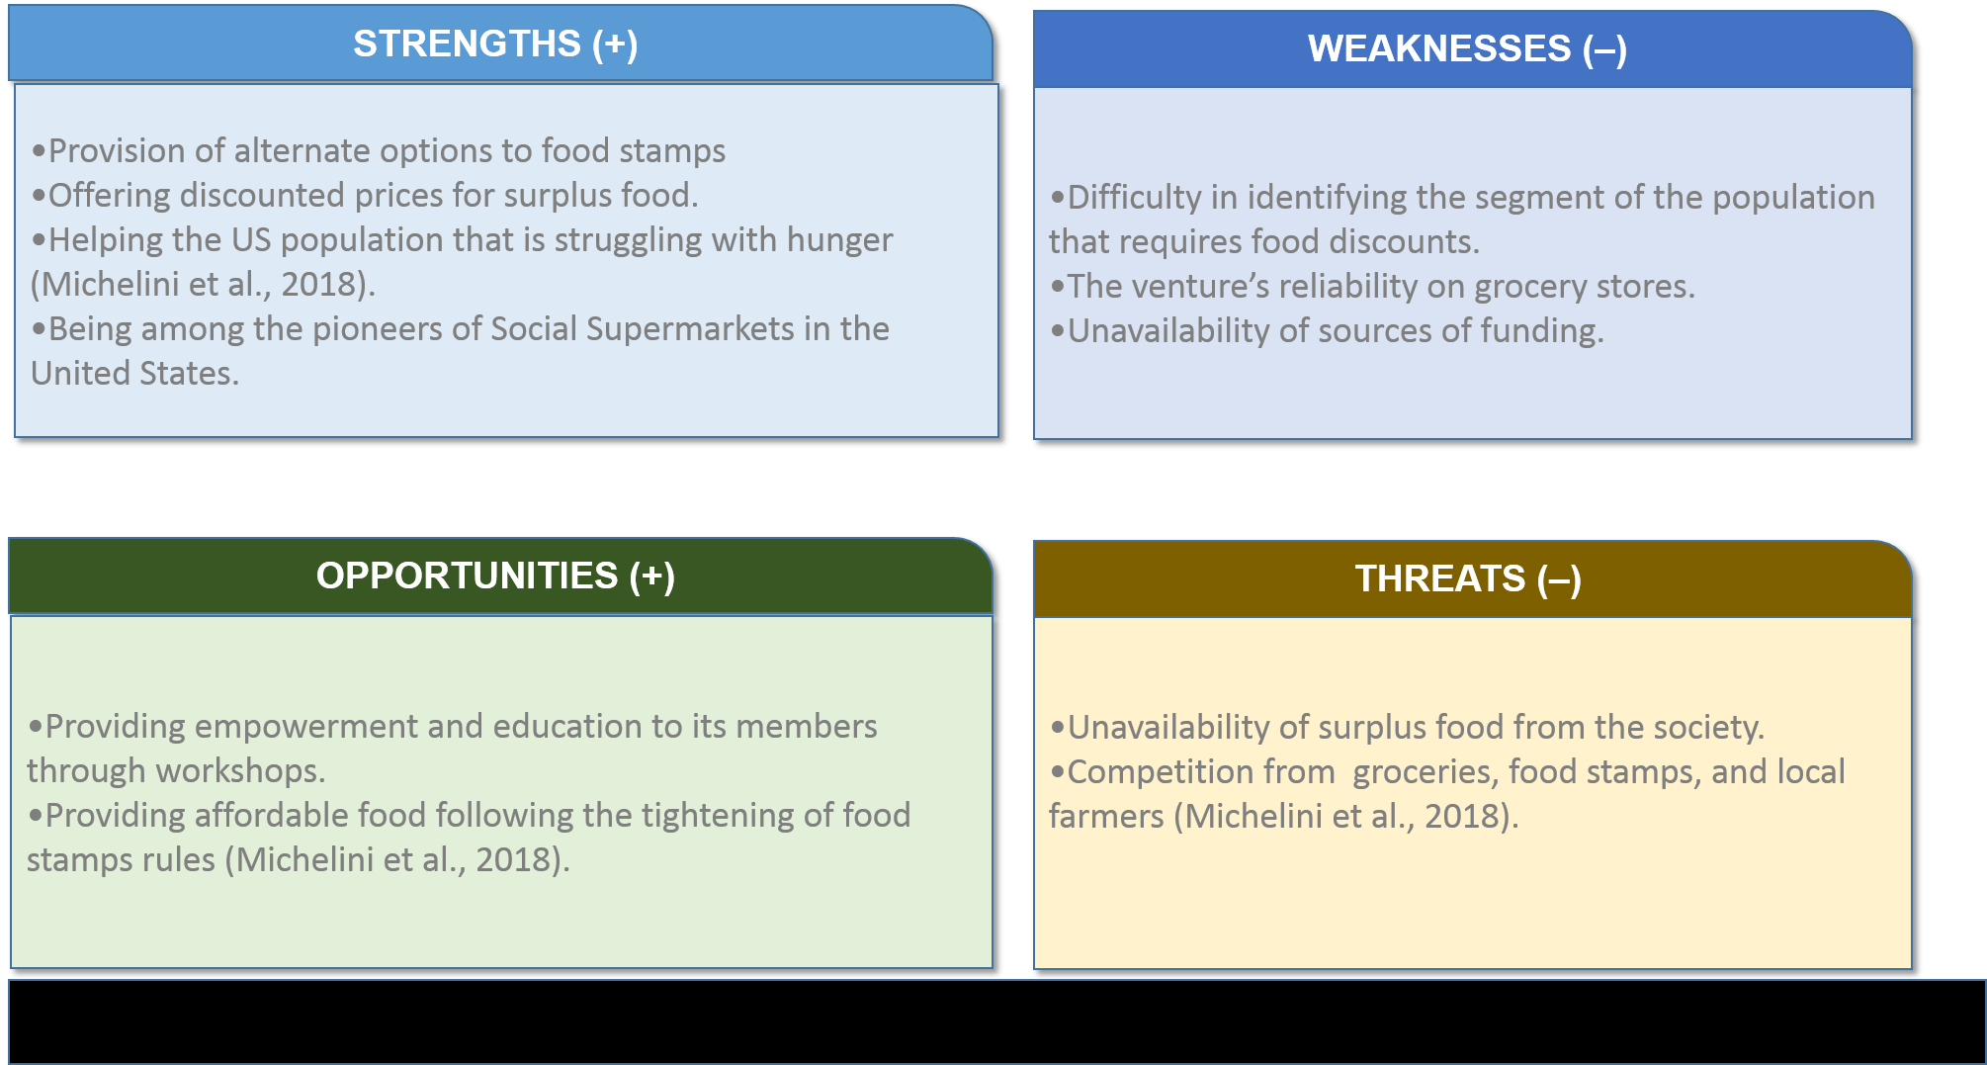
Drizzling Investments SWOT Analysis
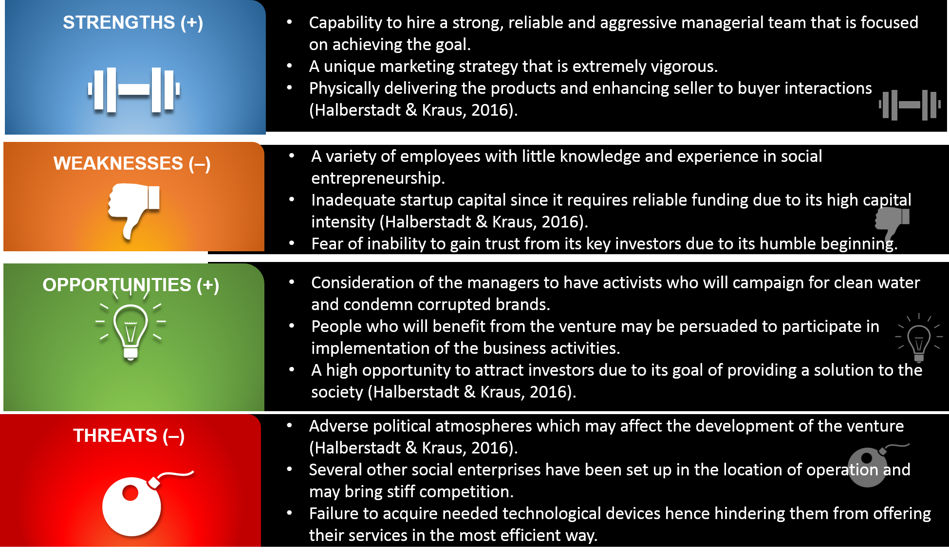
Conclusion
According to the SWOT analysis provided above, Blessings House Mobile Nursing Home decides to offer total funding of $500,000 to the two business ventures, each receiving $250,000. The business plans tabled by the two illustrate a dream that is indirectly parallel to the goals of Blessings House Mobile Nursing Home. The nursing home’s interests are to provide care for the elderly, the poor, and the sick while the two businesses offer a solution to these three groups.

References
Halberstadt, J., & Kraus, S. (2016). Social entrepreneurship: the foundation of tomorrow's commercial business models?. International Journal of Entrepreneurial Venturing, 8(3), 261-279.
Michelini, Laura, Ludovica Principato, and Gennaro Iasevoli. "Understanding food sharing models to tackle sustainability challenges." Ecological Economics 145 (2018): 205-217.

